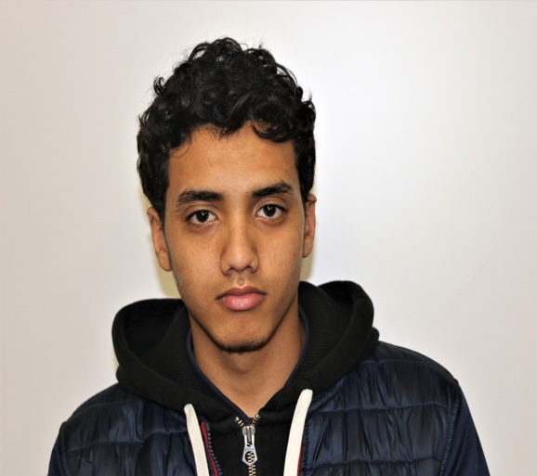

**From today on I affirm that…..**

I’m a man with Ambition, Inspiration and Motivation. My attitude and actions will transform this nation. I’m a man with Competence, Confidence and Character. I walk with integrity and return with honor. I’m Engaged, Educated, and Empowered; persistence and intelligence is the source of my power. I’m a man of distinction, living this life by design, moving forward together, no man left behind. #AIMHIGHEI

Written on: (Month, Year)

(First Name) is one of the distinguished Legacy Cohort Member of the AIMHigh Empowerment Institute @ Pelham Garden Middle School

Text Full Name Here HERE

My name is Salah Taleb. I was born in Yemen and spent a majority of my life living there. Now I live in New York City and attend the Life Sciences Secondary School.

My deepest aspiration has always been to join a team or be a part of an academy in New York City, but I’ve experienced much difficulty in this area because I found that many organizations are either full or not as inclusive. I truly enjoy sports and hope to become a pro soccer player. My journey has just begun, and I look forward to achieving greatness.

Text Full Name HERE