
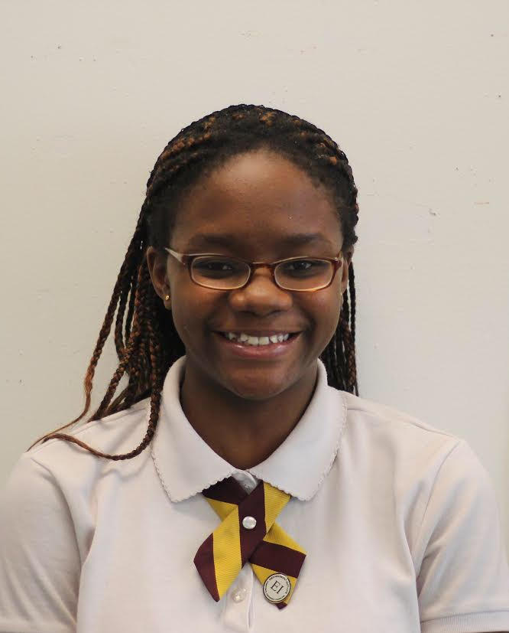
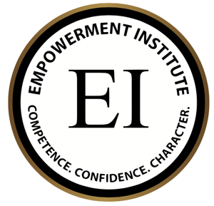
From today on I affirm that…..
I am a woman with ambition, inspiration and motivation. My attitude and actions will transform this nation. I’m a woman with competence, confidence and character. I walk with integrity, while leaving a legacy. I’m engaged, educated and empowered; endurance and wisdom is the source of my power. I’m a woman of distinction, living this life by design, moving forward together, all women unite. #AIMHIGHEI
Written on: (Month, Year)
(First Name) is one of the distinguished Legacy Cohort Member of the AIMHigh Empowerment Institute @ Bronx Career & College Preparatory High School.
Text Full Name Here HERE
My name is Anthonia Ogbennaya. I was born in Nigeria and spent majority of my time living there. Now I live in New York and attend Academy for Scholarship and Entrepreneurship.

My deepest aspiration has always been to be a pediatrician, but I have experienced much difficulty in this area because I have found that knowing all of the medical terms is challenging. In addition to, I truly enjoy reading stories like manga, watching animes, singing and dancing.

My journey has just begun and I look forward to what fate has set for me.
Text Full Name HERE

