

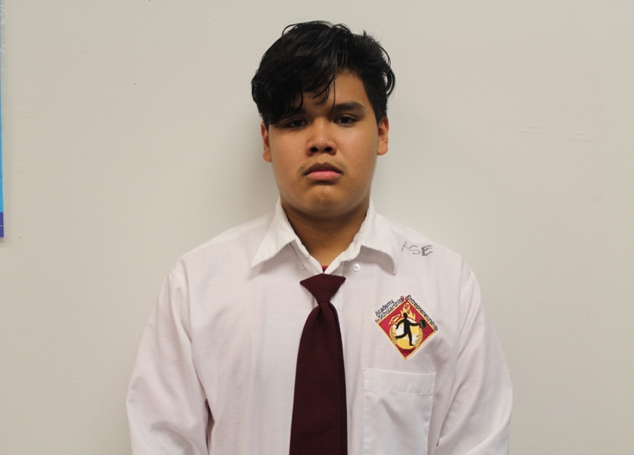
From today on I affirm that…..
I’m a man with Ambition, Inspiration and Motivation. My attitude and actions will transform this nation. I’m a man with Competence, Confidence and Character. I walk with integrity and return with honor. I’m Engaged, Educated, and Empowered; persistence and intelligence is the source of my power. I’m a man of distinction, living this life by design, moving forward together, no man left behind. #AIMHIGHEI
Written on: (Month, Year)
(First Name) is one of the distinguished Legacy Cohort Member of the AIMHigh Empowerment Institute @ Academy for Scholarship & Entrepreneurship.
Text Full Name Here HERE
I am Mainor Paz, a 16-year-old native of the Bronx. I attend Academy for scholarship and Entrepreneurship. I live with my mom, step-dad, sister and cousin. I really wish my life could be different at times, because I want to be a kid of honor: a kid who has made a positive and long lasting impact on the world that people could remember.

I want to be a change agent. I want to be with people that can help me be better academically, who challenge me and push me to be my best self. I am determined to succeed in life, follow me on this journey….
Text Full Name HERE

